

Hemp Quality Assurance Testing

CERTIFICATE OF ANALYSIS

DATE ISSUED 02/10/2025

|  |  |  |
| --- | --- | --- |
| SAMPLE DETAILS | |  |
| SAMPLE NAME: Tri Cannabinoid Chocolate Bar  Infused, Solid Edible  CULTIVATOR / MANUFACTURER  Business Name:  License Number:  Address:  SAMPLE DETAIL  Batch Number: 202501CT  Sample ID: 250123R012 | DISTRIBUTOR / TESTED FOR  Business Name: High End Confections License Number:  Address:  Date Collected: 01/23/2025  Date Received: 01/23/2025  Batch Size:  Sample Size: 3.0 units  Unit Mass: 55 grams per Unit  Serving Size: 4.58 grams per Serving | Scan QR code to verify authenticity of results. |
| CANNABINOID ANALYSIS - SUMMARY |  |  |
| Total THC: **47.080 mg/unit**  Total CBD: **96.250 mg/unit**  Sum of Cannabinoids: 331.265 mg/unit  Total Cannabinoids: 331.265 mg/unit | Total THC/CBD is calculated using the following formulas to take into account the loss of a carboxyl group during the decarboxylation step:  Total THC = ∆9-THC + (THCa (0.877))  Total CBD = CBD + (CBDa (0.877))  Sum of Cannabinoids = ∆9-THC + THCa + CBD + CBDa + CBG + CBGa +  THCV + THCVa + CBC + CBCa + CBDV + CBDVa + ∆8-THC + CBL + CBN  Total Cannabinoids = (∆9-THC+0.877*THCa) + (CBD+0.877*CBDa) +  (CBG+0.877*CBGa) + (THCV+0.877*THCVa) + (CBC+0.877*CBCa) +  (CBDV+0.877*CBDVa) + ∆8-THC + CBL + CBN |  |
| SAFETY ANALYSIS - SUMMARY |  |  |

∆9-THC per Unit: **PASS** ∆9-THC per Serving: **PASS** Microbiology (PCR): **PASS** Microbiology (Plating): **ND**

For quality assurance purposes. Not a Regulatory Hemp Lab Test Report. These results relate only to the sample included on this report. This report shall not be reproduced, except in full, without written approval of the laboratory.

Sample Certification: California Code of Regulations Title 4 Division 19. Department of Cannabis Control Business and Professions Code. Reference: Sections 26100, 26104 and 26110, Business and Professions Code.

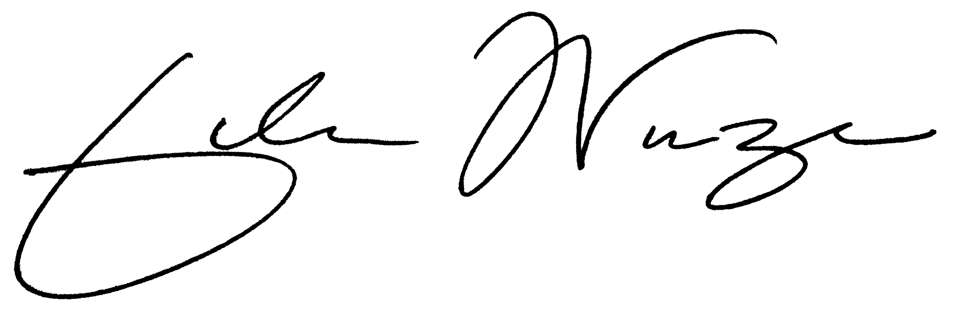

Approved by: Josh Wurzer

Job Title: Chief Compliance Officer

Date: 02/10/2025

Decision Rule: Statements of conformity (e.g. Pass/Fail) to specifications are made in this report without taking measurement uncertainty into account. Where statements of conformity are made in this report, the following decision rules are applied: PASS - Results within limits/specifications, FAIL - Results exceed limits/specifications.

References: limit of detection (LOD), limit of quantification (LOQ), not detected (ND), not tested (NT), μg/g = ppm, μg/kg = ppb, too numerous to count >250 cfu/plate (TNTC), colony-forming unit (cfu)

Amendment to Certificate of Analysis 250123R012-002 CoA ID: 250123R012-003 Summary Page



Hemp Quality Assurance Testing

CERTIFICATE OF ANALYSIS

DATE ISSUED 02/10/2025

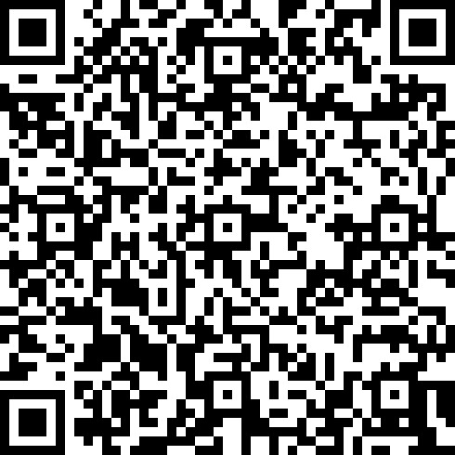

 Cannabinoid Analysis CANNABINOID TEST RESULTS - 01/27/2025

Tested by high-performance liquid **COMPOUND LOD/LOQ MEASUREMENT RESULT RESULT**

|  |  |  |  |  |
| --- | --- | --- | --- | --- |
| CBG | *0.002 / 0.006* | *±0.1657* | 3.417 | 0.3417 |
| CBD | *0.004 / 0.011* | *±0.0653* | 1.750 | 0.1750 |
| ∆9-THC | *0.002 / 0.014* | *±0.0470* | 0.856 | 0.0856 |
| CBDV | *0.002 / 0.012* | *N/A* | <LOQ | <LOQ |
| ∆8-THC | *0.01 / 0.02* | *N/A* | ND | ND |
| THCa | *0.001 / 0.005* | *N/A* | ND | ND |
| THCV | *0.002 / 0.012* | *N/A* | ND | ND |
| THCVa | *0.002 / 0.019* | *N/A* | ND | ND |
| CBDa | *0.001 / 0.026* | *N/A* | ND | ND |
| CBDVa | *0.001 / 0.018* | *N/A* | ND | ND |
| CBGa | *0.002 / 0.007* | *N/A* | ND | ND |
| CBL | *0.003 / 0.010* | *N/A* | ND | ND |
| CBN | *0.001 / 0.007* | *N/A* | ND | ND |
| CBC | *0.003 / 0.010* | *N/A* | ND | ND |
| CBCa | *0.001 / 0.015* | *N/A* | ND | ND |

**(mg/g) UNCERTAINTY (mg/g) (mg/g) (%)** chromatography with diode-array detection (HPLC-DAD).

**Method:** QSP 1157 - Analysis of Cannabinoids by HPLC-DAD

TOTAL THC: **47.080 mg/unit**

Total THC (∆9-THC+0.877*THCa)

TOTAL CBD: **96.250 mg/unit**

Total CBD (CBD+0.877*CBDa)

# TOTAL CANNABINOIDS: 331.265 mg/unit

Total Cannabinoids (Total THC) + (Total CBD) +

(Total CBG) + (Total THCV) + (Total CBC) +

(Total CBDV) + ∆8-THC + CBL + CBN

# TOTAL CBG: 187.935 mg/unit

Total CBG (CBG+0.877*CBGa)

## SUM OF CANNABINOIDS 6.023 mg/g 0.6023%

# TOTAL THCV: ND

Total THCV (THCV+0.877*THCVa)

Unit Mass: 55 grams per Unit / Serving Size: 4.58 grams per Serving

# TOTAL CBC: ND

|  |  |  |  |
| --- | --- | --- | --- |
| ∆9-THC per Unit | *110 per-package limit* | 47.080 mg/unit | PASS |
| ∆9-THC per Serving |  | 3.920 mg/serving | PASS |
| Total THC per Unit |  | 47.080 mg/unit |  |
| Total THC per Serving |  | 3.920 mg/serving |  |
| CBD per Unit |  | 96.250 mg/unit |  |
| CBD per Serving |  | 8.015 mg/serving |  |
| Total CBD per Unit |  | 96.250 mg/unit |  |
| Total CBD per Serving |  | 8.015 mg/serving |  |
| Sum of Cannabinoids per Unit |  | 331.265 mg/unit |  |
| Sum of Cannabinoids per Serving |  | 27.585 mg/serving |  |
| Total Cannabinoids per Unit |  | 331.265 mg/unit |  |
| Total Cannabinoids per Serving |  | 27.585 mg/serving |  |

Total CBC (CBC+0.877*CBCa)

# TOTAL CBDV: <LOQ

Total CBDV (CBDV+0.877*CBDVa)

CoA ID: 250123R012-003 Page 2 of 3

Hemp Quality Assurance Testing

# CERTIFICATE OF ANALYSIS

## DATE ISSUED 02/10/2025

|  |  |  |  |  |
| --- | --- | --- | --- | --- |
| Microbiology Analysis  PCR AND PLATING  Analysis conducted by polymerase chain reaction  PCR) and fluorescence detection of microbiological contaminants.  **Method:** QSP 1221 - Analysis of Microbiological Contaminants  Analysis conducted by 3MTM PetrifilmTM and plate counts of microbiological contaminants.  **Method:** QSP 6794 - Plating with 3MTM PetrifilmTM | MICROBIOLOGY TEST RESULTS (PCR) - 02/07/2025  PASS  **COMPOUND ACTION LIMIT** | | **RESULT** | **RESULT** |
| ***Salmonella*** spp. | *Not Detected in 1g* | ND | PASS |
| Shiga toxin-producing ***Escherichia coli*** | *Not Detected in 1g* | ND | PASS |
| MICROBIOLOGY TEST RESULTS (PLATING) - 02/07/2025 ND  **COMPOUND** | |  | **RESULT**  **(cfu/g)** |
| Total Yeast and Mold | |  | ND |

(

## NOTES

Reason for Amendment: Order Detail Information Change Sample unit mass provided by client.

CoA ID: 250123R012-003 Page 3 of 3